Day 2:
Task 1:
Devices Using SMPS (Switched Mode Power Supply) :
An SMPS is highly efficient, compact, and converts voltage levels precisely, making it ideal for electronics with sensitive internal components.

- Desktop Computer / CPU: It requires an SMPS to efficiently convert high-voltage AC electricity from the wall into multiple precise, low-voltage DC channels ($+3.3"V"$, $+5"V"$, $+12"V"$) required by the motherboard and components.

- LED Television: It uses an SMPS because its lightweight, compact design easily fits into slim television frames while safely stepping down voltage to power the display backlights and processing chips.

. Mobile Phone Charger: It utilizes a miniature SMPS to quickly and efficiently convert AC mains power into a
safe, regulated $5"V"$ or $9"V"$ DC output without generating excessive heat in a tiny adapter.

. Devices Using UPS (Uninterruptible Power Supply)

A UPS acts as a battery backup, ensuring zero downtime and protecting critical systems from data loss or damage during sudden power outages.
- Wi-Fi Router: It needs a UPS to keep the internet connection live and uninterrupted during local power cuts, ensuring continuous online classes, exams, or work.
- College Computer Lab Servers: They rely on heavy-duty UPS systems to prevent catastrophic data corruption, keep network databases accessible, and allow administrators time to safely shut down systems during a blackout.

TASK 2:
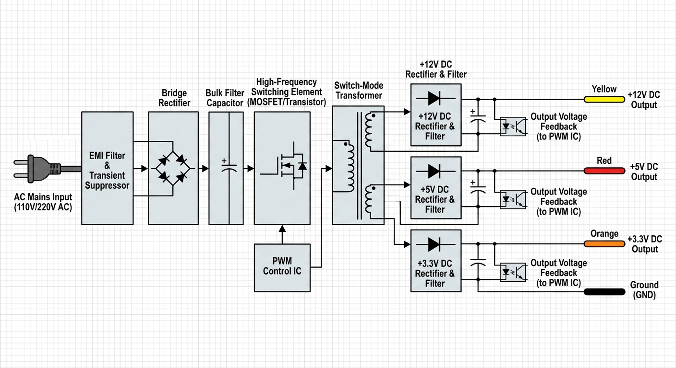

TASK 3:
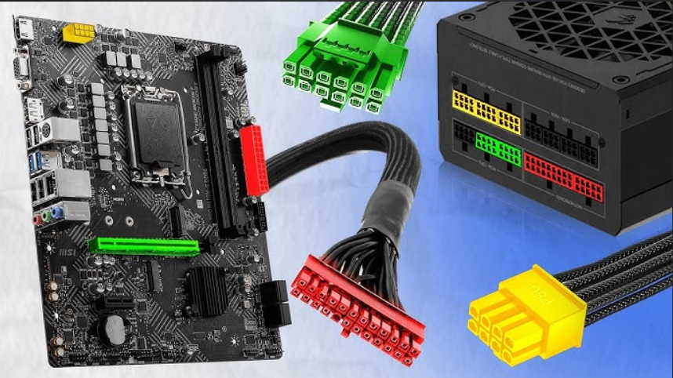
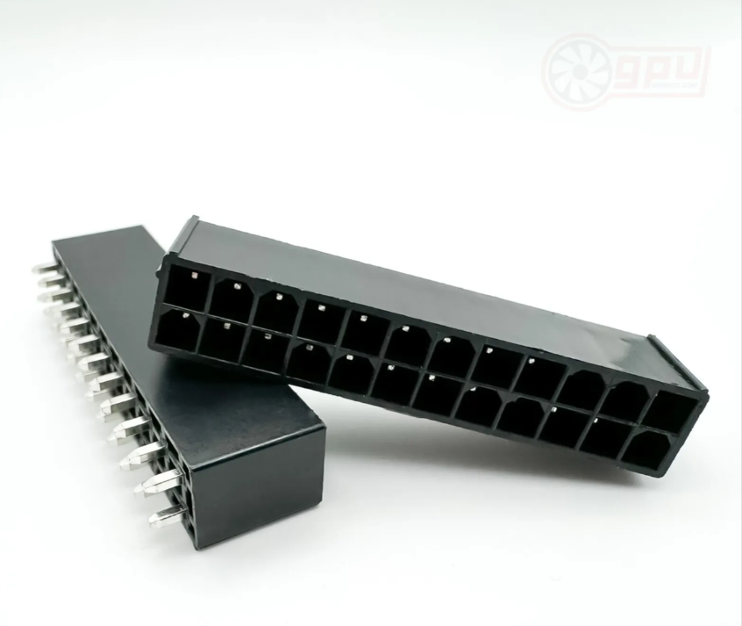
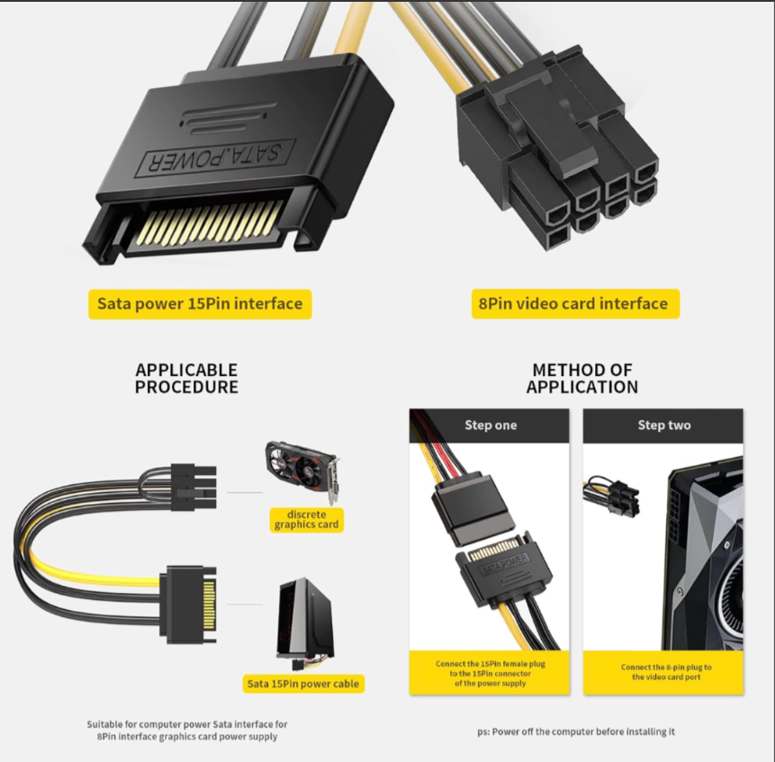
1. ATX 24-Pin Motherboard Connector :
- Devices it powers: Delivers primary power to the entire motherboard, distributing electricity to the chipset, RAM, PCIe slots, and low-power integrated components.
- Safety Tip: Always press down fully on the plastic retention clip to release the latch before pulling, and gently rock the connector side-to-side rather than yanking it straight up to prevent cracking the motherboard PCB.

2. SATA Power Connector :
- Devices it powers: Powers modern storage drives including 2.5-inch Solid State Drives (SSDs), 3.5-inch Hard Disk Drives (HDDs), and optical drives (like DVD/Blu-ray writers).
- Safety Tip: Ensure the connector's distinct "L-shaped" guide slot aligns perfectly with the drive's port before applying pressure, as forcing it upside down can easily snap the fragile plastic guide key inside the drive.
3. Molex Connector (4-Pin Peripheral) :
- Devices it powers: Traditionally used for older IDE hard drives, but now primarily powers secondary PC peripherals such as case fans, RGB lighting controllers, liquid cooling pumps, and some legacy expansion cards.
- Safety Tip: The internal metal pins inside a Molex connector can easily wobble or become misaligned; always check that the pins are straight before plugging it in to prevent pushing a live pin backward and risking a short circuit.
4. PCIe 6/8-Pin Connector :
- Devices it powers: Delivers dedicated high-wattage power directly to discrete graphics cards (GPUs) to supplement the power provided by the motherboard slot.
- Safety Tip: If using a split "6+2 pin" variant to fill an 8-pin socket, make sure the small interlocking tabs on the 2-pin section are securely seated underneath the 6-pin housing before sliding the assembly completely into the graphics card.

TASK 4:
Step 1: Mount the SMPS
Before plugging anything in, secure the SMPS into the PC case's designated power supply bay (usually at the bottom) using the provided screws. Ensure the power supply fan is facing the correct direction—usually downward if your case has a bottom ventilation grill and dust filter.

Step 2: Power the Motherboard (Main & CPU Power)

The motherboard requires two completely separate power connections to boot.
- The Main Power: Locate the thickest cable on your SMPS—the ATX 24-pin connector. Align the plastic latch on the cable with the ridge on the long 24-pin slot on the right side of the motherboard. Press firmly until the clip clicks into place.
- The CPU Power: Locate the EPS / CPU 8-pin (or 4+4 pin) cable. This plugs into the top-left corner of the motherboard near the rear I/O panel. Tip: Do not confuse this with a PCIe cable; CPU cables are usually labeled "CPU" and split cleanly down the middle into two 4-pin halves.

Step 3: Power the Graphics Card (GPU)
Gaming GPUs are power-hungry and need dedicated lines straight from the SMPS.
- The Connection: Locate the PCIe 6+2 pin cables (often labeled "PCI-E"). Depending on your graphics card's requirements, you may need one or two of these.
- The Method: If your card requires an 8-pin connection, slot the small 2-pin attachment into the 6-pin block first, then slide the combined 8-pin connector into the GPU until it clicks. For high-end modern cards (like the RTX 40-series), you will use a dedicated 12VHPWR (12+4 pin) cable instead. Ensure it is pushed entirely flush into the GPU socket to avoid uneven power delivery.

Step 4: Power the Storage Devices
If you are using modern M.2 NVMe SSDs, they draw power directly from the motherboard slot and don't need cables. However, if you have 2.5-inch SATA SSDs or 3.5-inch Hard Drives:
- The Connection: Find the ribbon-like cable coming from your SMPS that features wide, flat SATA power connectors.
- The Method: Line up the distinct "L-shaped" notch inside the connector with the power port on your SSD or HDD and slide it in.

Step 5: Double-Check and Cable Manage
Before flipping the power switch, gently tug on each connector to ensure the retention clips are fully locked. Route the excess slack through the back of your PC case using zip ties or straps to keep the interior clean and maximize airflow. Finally, plug the main AC power cord into the back of the SMPS and flip its master switch to the (On) position.

